|  |
| --- |
| C:\Users\jdauksaite\Downloads\ind_man_glb_ho_2279.png |



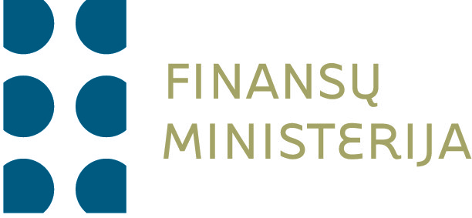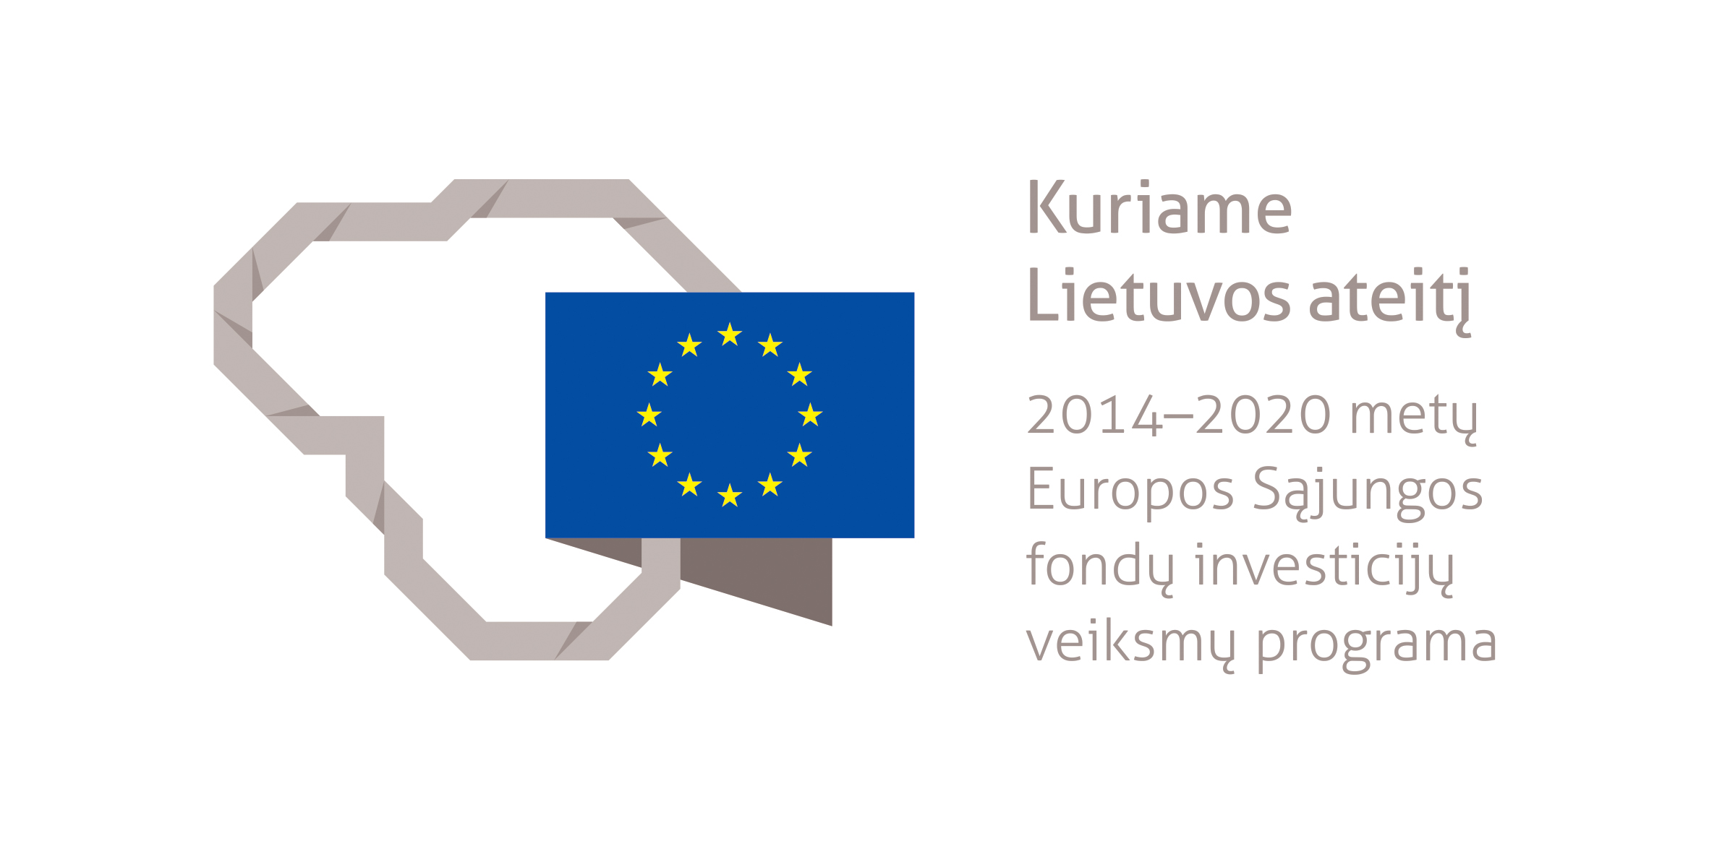

|  |
| --- |
| Evaluation of 2007 – 2013 EU structural assistance impact on sustainable development in Lithuania  Summary |

|  |
| --- |
| Evaluation of 2007 – 2013 EU structural assistance impact on sustainable development in Lithuania | Summary |

|  |
| --- |
| Deloitte Lietuva UAB, in collaboration with Integra Consulting Ltd., performed an evaluation of the impact of 2007–2013 European Union (hereinafter – EU) structural assistance on sustainable development in Lithuania for the Ministry of Finance of the Republic of Lithuania. The purpose of the evaluation – determining the impact of 2007–2013 EU structural assistance on sustainable development, with the objective to appropriately account for the implementation of funds during the period of 2007–2013 and to improve the implementation of funds during 2014–2020. |

Summary

# 

Deloitte Lietuva UAB, in collaboration with Integra Consulting Ltd., performed an evaluation of the impact of 2007–2013 European Union (hereinafter – EU) structural assistance on sustainable development in Lithuania for the Ministry of Finance of the Republic of Lithuania. The purpose of the evaluation – determining the impact of 2007–2013 EU structural assistance on sustainable development, with the objective to appropriately account for the implementation of funds during the period of 2007–2013 and to improve the implementation of funds during 2014–2020.

Furthermore, the purpose of the evaluation is divided into two subtasks:

1. Evaluating the integration of the principles (suitability, adequacy, consistency) of sustainable development priority into the 2007–2013 operational programme implementation
2. Evaluating the implementation (effectiveness, impact) of the horizontal priority objectives of sustainable development, as provided in the Lithuanian strategy of adopting the 2007–2013 EU structural assistance (hereinafter – Strategy) and the operational programmes of its implementation (with the exception of Technical Assistance Operational Programme)

The object of the evaluation is the Lithuanian strategy of adopting 2007–2013 EU structural assistance (hereinafter – Strategy) and the operational programmes of its implementation: Operational Programme for the Development of Human Resources (OPDHR), Operational Programme for the Economic Growth (OPEG) and Operational Programme for the Promotion of Cohesion (OPPC) (i. e. all programmes with the exception of Technical Assistance Operational Programme).

The scope of the evaluation covers the analysis of the EU structural support measures (a total of 95) as well as strategic context and sustainable development indicators reflecting their investments, which were identified having evaluated their compliance with the sustainable development objectives of the horizontal priority (mitigating climate change and adapting to it; transport development and reducing negative environmental impact; promotion of sustainable production and consumption in order to improve environmental resource management; mitigating poverty and social exclusion; reducing public health threats; tackling demographic and emigration problems).

**Overall, 130 indicators have been selected for the analysis (excluding division by sectors, regions or types of pollutants), 48 of which are strategic context indicators, 82 – indicators reflecting the implementation of sustainable development objectives of the National Sustainable Development Strategy (19 of them are eco-efficiency indicators). During the indicator selection process, the guidelines of horizontal priority implementation were followed as well as the 2008 evaluation of horizontal priority implementation while absorbing the EU structural assistance.**

The following challenges (risks) are related to the implementation of evaluation steps and the application of evaluation methods:

* Horizontal nature of the evaluated object
* Complex and mixed policy funded by structural funds (SF), the European Social Fund (ESF), the European Regional Development Fund (ERDF) and the Cohesion Fund (CF)
* Significant influence of contextual factors (economic situation, industry trends etc.)
* Considerable influence of political factors, determining complex tracing of political decision-making process

With the purpose of managing the above risks, the model of the theory of change evaluation was applied, based on the principles of realism paradigm. Evaluation based on realism paradigm assumptions differs from contribution analysis usually applied in Lithuanian evaluations of the EU structural assistance absorption and impact evaluations, by emphasising target groups of interventions and their decisions as well as the influence of context. The main assumption of this theoretical approach states that the reaction of target group members (or absence thereof) to the opportunities opened by the intervention predetermines the effect of the intervention (positive/neutral/negative).

# The evaluation was performed applying both data collection and data analysis methods. While analysing the available information, not only primary and secondary sources were considered, but also SFMIS2007 project monitoring data and statistical data were analysed, which were later used in the regression analysis. During the evaluation, a survey of the institutions administering the EU structural funds and 50 interviews with both representatives of responsible authorities and institutions and with the social – economic partners were carried out. The horizontal nature of the evaluated object required an especially close participation of all stakeholders; therefore, focus group discussions and international expert panels were organised to serve the purpose. To survey the regional dimension, 14 case studies of problem territories as well as three case studies of foreign countries (the Czech Republic, Slovenia and Austria) were carried out. The conclusions were drawn through expert evaluation and statistical as well as comparative analysis.

## Evaluation Findings and Strategic Recommendations

## Impact of social - economic situation on sustainable development goals

According to the Statistics Lithuania, the main social – economic indicators of Lithuania include citizens’ employment/unemployment, the level of inflation and GDP changes. In addition, to strengthen the social (social cohesion) dimension which is directly related to social capital resources and the sustainable development concept, poverty rate has been included in the list of indicators. The evaluation examines the dynamics of the main indicators of Lithuania for 2007–2013 and provides a comparison with other EU-28 member states. Moreover, in order to answer the question, the impact of the changes in the social – economic situation on the horizontal priority objectives of sustainable development are analysed:

* Mitigating climate change and adapting to it
* Transport development and reducing negative environmental impact
* Promotion of sustainable production and consumption
* Improved management of environmental resources
* Mitigating poverty and social exclusion
* Reducing public health threats
* Tackling demographic and emigration problems

In both Lithuania and the EU (on average), all the analysed indicators reflecting social – economic situation changed in a similar trend: the financial crisis had the greatest impact on the indicators; 2010 can be considered the breaking point, when the majority of the indicators began to reflect positive trends.

The EU structural assistance was one of the main measures of mitigating the outcomes of the financial crisis. The situation in 2008–2010 required fast solutions which were not always interoperable. The solutions resulting from the financial crisis and reallocation of funds were often directed towards managing the outcomes of the crisis, and not towards the long-term outlook (sustainable development). In conclusion, the financial crisis had a negative impact on the areas of human, social and manufactured capital, while in case of natural capital a positive impact was identified (eg. lower exhaust gas and amount of waste due to the production slowdown).

**EU structural assistance‘s input for successful implementation of sustainable development horizontal priority**

The contribution of the EU structural assistance directed towards sustainable development throughout 2007–2013 was evaluated on the basis of the Four Capital Model (capital resources are divided into four types: natural, manufactured, social and human). For the evaluation, separate measures were analysed in accordance with the type of capital the interventions of measures belong to.

During the EU structural funds’ programming period of 2007–2013, Lithuania invested mostly in the manufactured capital (funds in Euros, including both the EU funding and the Lithuanian budget allocations), while investments in other three capital areas distributed quite evenly.

From the vertical point of view, investments in different types of capital were uneven; however, assessing horizontally the distribution of investments was relatively even as, for instance, the dimension of natural capital was identified in manufactured capital as well.

Vertinant pagal atskiras 2007 – 2013 m. veiksmų programas, daugiausiai į žmogiškąjį kapitalą buvo investuota ŽIPVP apimtyje, tuo tarpu EAVP ir SSVP atveju didžiausio dėmesio sulaukė gamybinis kapitalas. Šios tendencijos atitinka veiksmų programų finansavimo kryptis ir keltus tikslus.

|  |  |  |
| --- | --- | --- |
| Table 1. Impact of social – economic situation on different horizontal priority objectives of sustainable development | | |
| Sustainable development objective | Impact of social – economic situation | Comment |
| 1. Mitigating climate change and adapting to it | Negative | In 2011–2012, GHG emission growth trends were identified in industry, energy, transport and other sectors. However, emission levels grew in industry and energy sectors, and somewhat declined in transport sector. |
| 2. Transport development and reducing negative environmental impact | Neutral | No significant impact identified. |
| 3. Promotion of sustainable production and consumption | Negative | Social – economic situation brought imbalance to industry sector, shifting the focus away from sustainable and advanced technology-based manufacturing to tackling short-term challenges (eg. declining production volumes). |
| 4. Improved management of environmental resources | Neutral | The impact of social – economic situation was not negative due to relatively large investments in wastewater management systems. In addition, with the economic slowdown and decreasing volumes in production and consumption, emissions of waste decreased as well, which altogether positively contributed to the preservation of environmental resources. |
| 5. Mitigating poverty and social exclusion | Negative | Deteriorating social – economic situation in both the EU and Lithuania negatively impacted the member states’ indicators of social cohesion. Many countries aimed to mitigate the effects of the financial crisis by applying austerity measures; this led to the reduction of expenditure on social policy. |
| 6. Reducing public health threats | Neutral | Social – economic situation did not have a significant impact on the objective of the horizontal priority of sustainable development. The EU structural assistance for health sector infrastructure as well as the prevention of a variety of disease and addiction problems saved from the impairment of public health indicators. |
| 7. Tackling demographic and emigration problems | Negative | Social – economic situation had a significant negative impact on demographic and emigration problems. |
| Source: concluded by Evaluators |  |  |

Assessing in terms of different 2007–2013 operational programmes, the majority of investments in human capital were made under the scope of OPDHR, while in the cases of OPEG and OPPC manufactured capital received the most attention. Those trends reflect the financing tendencies and goals of operational programmes. Accordingly, while selecting the measures included the Evaluation object, the purpose was evenly covering all three operational programmes, three EU structural funds, the objectives of sustainable development priority and the four types of capital.

In order to assess which priorities and measures of the operational programmes contributed the most to the implementation of the principle of sustainable development, the analysis of draft project financing terms of the measures (PFTM) was performed, and the assessment of the main horizontal priority objectives of sustainable development were carried out. During the expert evaluation, the operational programme measures were linked to sustainable development goals and strategic context indicators of sustainable development (including eco-efficiency) as well as operational programmes, designated for assessing them. The allocation of the 2007–2013 EU structural assistance measures to different types of capital is provided in Annex 6 to this Report. The same Annex provides the links between the measures and separate sustainable development and strategic context indicators.

**Picture 1. Distribution of EU structural funds investments**

Source: 2015-12-31 www.esparama.lt

Assessing in terms of different 2007–2013 operational programmes, the majority of investments in human capital were made under the scope of OPDHR, while in the cases of OPEG and OPPC manufactured capital received the most attention. Those trends reflect the financing tendencies and goals of operational programmes. Accordingly, while selecting the measures included the Evaluation object, the purpose was evenly covering all three operational programmes, three EU structural funds, the objectives of sustainable development priority and the four types of capital.

In order to assess which priorities and measures of the operational programmes contributed the most to the implementation of the principle of sustainable development, the analysis of draft project financing terms of the measures (PFTM) was performed, and the assessment of the main horizontal priority objectives of sustainable development were carried out. During the expert evaluation, the operational programme measures were linked to sustainable development goals and strategic context indicators of sustainable development (including eco-efficiency) as well as operational programmes, designated for assessing them. The allocation of the 2007–2013 EU structural assistance measures to different types of capital is provided in Annex 6 to this Report. The same Annex provides the links between the measures and separate sustainable development and strategic context indicators.

The impact of all 2007–2013 projects on sustainable development was evaluated as early as in the stage of performing the financing eligibility assessment of project applications, and projects with potential negative impact were not considered. Therefore, it can be assumed that all 2007–2013 investments had a neutral or positive impact on sustainable development in Lithuania on the operational (project/programme) level.

Having performed the PFTM analysis (the results are provided in Annex 7 of the Report), measures having direct and indirect impact on sustainable development were identified. The measures of the EU structural funds, which integrate the horizontal priority of sustainable development vertically, were considered to have direct impact on sustainable development. The measures of the EU structural funds, which integrate the horizontal priority of sustainable development horizontally or horizontally while also incorporating additional proactive measures in a specific area, were considered to have indirect impact on sustainable development.

The evaluation identified that all the following OPEG measures contributed directly to the horizontal priority of sustainable development: 2.4. priority, “Basic Economic Infrastructure”; measures of the 2.5. priority, “Trans-European Transport Network Development” and part of the OPPC measures of the 3.1. priority, “Local and Urban Development; Preservation of Cultural Heritage and Environment as well as Adaptation for Tourism Development”; and the 3.3. priority, “Environment and Sustainable Development”. Detailed analysis of these priorities and measures is provided below.

Case studies of 2007–2013 target investments of the EU structural funds in 14 problem territories as well as regression analysis have identified that the EU structural assistance measures had the greatest impact on the resources of manufactured and natural capital. This conclusion is also consistent with the scope of investments in manufactured and natural capital during the period of 2007–2013.

**Measures for implementing sustainable development horizontal priority**

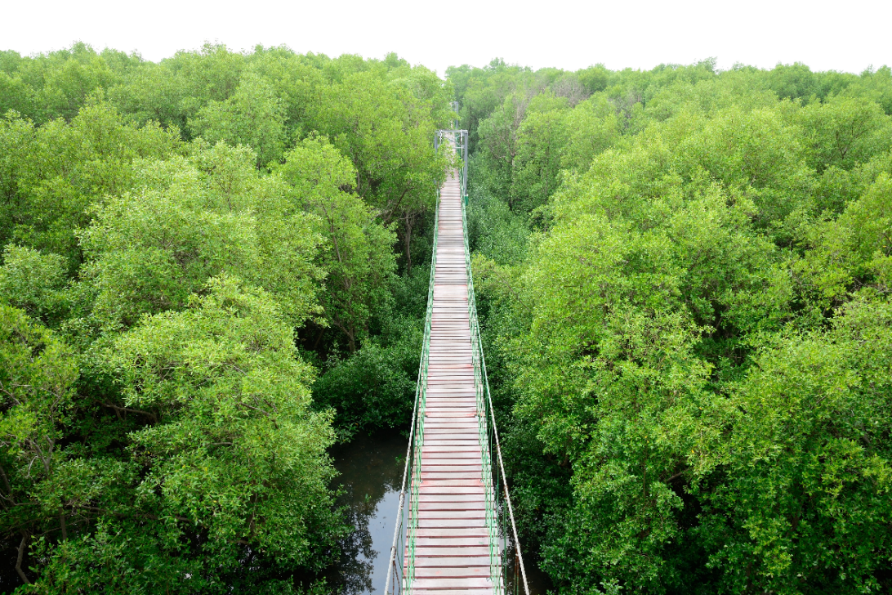To efficiently implement sustainable development goals in the context of structural funds, three types of integration instruments were applied throughout the whole programming and project implementation period: strategic, procedural and organisational instruments.

Strategic instruments assure accurate compliance and sustainability with the Cohesion policy programmes and determines adequate financing. Those instruments help to conceptualise a vision, objectives and strategies, the implementation of which is left to the responsibility of member states.

Procedural instruments cover evaluation, monitoring procedures and reporting. The purpose of those instruments is the improvement of policy-making procedures and operations. However, the said instruments often face political resistance and increase administrative burden.

Organisational instruments deal with the changes in institutional structure, promotion of cooperation and consulting. The potential of those instruments involves reinforcing the positions of institutions and attracting new stakeholders.

All three groups of instruments correlate and complement each other.

In Lithuania, strategic instruments involve the National Sustainable Development Strategy and sectoral programmes related to it. On the other hand, the position and relevance of the National Sustainable Development Strategy in the system of other Lithuanian strategic planning documents remains one of the biggest weaknesses. Considering the content of the sustainable development principle and the fact that the National Sustainable Development Strategy is aimed towards a long-term social, economic and environmental development of the country, it is crucial to identify its links with the National Progress Programme “Lithuania 2030”.

The principle of sustainable development incorporates consistent development of a specific territory, based on social – economic development without negative environmental impact. Based on this definition, all national/regional/local municipal documents are measures or instruments of the implementation of the sustainable development principle. The Ministry of Environment of the Republic of Lithuania is currently responsible for the implementation of the National Sustainable Development Strategy. The National Commission for Sustainable Development is monitoring the National Sustainable Development Strategy. The evaluation identified that assigning such horizontal area to a sectoral ministry in the context of Lithuanian interinstitutional cooperation challenges predefines a lack of attention to the issues of sustainable development and limited compatibility with other sectoral strategies. In addition, rare and irregular meetings of the National Commission for Sustainable Development do not assure adequate attention to the implementation of the strategy and to linking it to the sectoral development strategies.

An additional strategic instrument associated with the current sectoral nature is the appointment of one national coordinator for the implementation of the sustainable development principle. As foreign practice shows, decision-making on the Governmental level assures wider political attention and, as a result, more streamlined strategic management decisions.

Procedural instruments, similarly to the strategic ones, are usually designed to solve environmental issues. Strategic environmental impact assessment (hereinafter – SEIA) is a process of determining, defining and evaluating potential impact. During the assessment, SEIA documents are drawn; consulting takes place; before adopting and/or approving a plan or a programme, evaluation and consulting results are considered; information related to adopting/approving a plan or a programme is provided.

Generally, SEIA is a compulsory document, rather strictly defined by the EC; therefore, all member states, including Lithuania, apply it to a certain extent. There are more issues related to the actions of regular review of its conclusions and not the application of the instrument itself. The usual practice (including Lithuania) is seriously regarding SEIA during the programming period, but once an operational programme is completed and approved by the EC, SEIA is not reviewed regularly in accordance with the amendments of the operational programme and measures financed by it.

The purpose of another instrument, environmental impact assessment (hereinafter – EIA), is assuring that the responsible institution adopting a decision regarding the legitimacy of operations in a chosen area would have sufficient information about the potential environmental impact of those operations as well as the possibilities to mitigate their impact, and would be aware of the public opinion. In Lithuania, EIAs were performed only for several of the four OPEG and OPPC priority measures. EIA is applicable to infrastructure and environmental projects, and the main challenge is the capabilities of the implementing institutions to evaluate the quality of such assessments. Therefore, to assure EIAs are truly useful, it is recommended to perform them as early as in the project planning stage before including the project in the list of national/regional project plans.

Territorial impact assessment (hereinafter – TIA) is designed for assessing the impact of various EU political instruments in a specific territory. TIA may seem unusual due to its complex nature, large-scale analyses and various impact assessments. The essence of this tool is identifying an anticipated as well as unexpected impact of various instruments. It is important to emphasise that different EU structural funds invest in separate territories in Lithuania, and other financial assistance is used as well (eg. EEA, Norwegian, Swiss financial assistance funds). No assessments were performed during 2007–2013, which would evaluate complex financial investments and their interoperability, divides and potential overlaps. TIA performed, for instance, by the Office of the Government or separate local municipalities would ensure a more targeted use of funds.

The evaluation also identified that the major attention to the horizontal principle of the sustainable development is given in the environmental sector. The horizontal principle of the sustainable development is also relevant for urban development, diversification of economic activity, issues of environmental regulation implementation; however, evaluating investments in the public sector or the impact of the EU structural assistance on the quality of life, social exclusion and poverty mitigation in Lithuania, not enough attention is paid to the horizontal priorities (i. e. sustainable development).

Having performed the PFTM analysis of the 2007–2013 programming period, the evaluation identified that in most cases (appr. 80%) the horizontal priority of sustainable development is implemented using the integrated (horizontal) method. Only for 20% of all analysed measures, the horizontal priority was implemented using differentiated (vertical) method. Integrated implementation methods in Lithuania include an application provided by a project developer, covering the description of the neutral impact on sustainable development or non-violation thereof. Thus, integrated implementation methods involve passive measures.

Differentiated implementation method in Lithuania during 2007–2013 involved measures like SEIA, EIA, special selection criteria and special EU structural fund financing measures for sustainable development. Although the impact of vertically integrated sustainable development principle (through special EU structural fund financing measures) on sustainable development is the most obvious and significant, according to some of the respondents having participated in the Evaluation, such attitude narrows down the concept of the horizontal priority and debases its horizontal aspect. Foreign country analysis revealed that having supplemented separate investment directions with one vertical sustainable development priority, aimed at increasing interoperability with other specific investment priorities, can successfully serve the implementation of sustainable development principle on a national and regional level.

The third type – organisational instruments – include institutional capabilities, cooperation, operations of the monitoring committee and the establishment of various institutional networks. The EU fund programmes made an indirect positive impact on the management systems of the member states. During the Evaluation (applying the methods of interview and survey) it was identified that a considerable amount of theoretical knowledge about sustainable development is accumulated in the Lithuanian administrative system. Nonetheless, the main challenges lie in the ability to practically apply the theoretical definition. The activity of the monitoring committee and working group was evaluated rather sceptically, more attention giving to specific examples of the integration of the horizontal priority of sustainable development as well as foreign practice. It is important that the greater extent of the knowledge is accumulated on the ministry level, which most administration members of the EU structural funds regard as the main subjects responsible for the horizontal priorities and their implementation. The evaluation identified that the education of the employees of implementation institutions of the EU structural funds’ administrative system remains one of the greater shortcomings: on this institutional level, less attention is given to the horizontal priority of sustainable development than to other, more technical issues, and the knowledge of the employees, who consult on practical matters of sustainable development, is limited.

The evaluation determines that strategic, procedural and operational measures are applied in Lithuania. But in order to successfully integrate and implement the principle of sustainable development, it is crucial to fortify strategic management (ensuring the links between the National Sustainable Development Strategy and the main national and sectoral strategic documents, sustaining consistent monitoring of strategy indicators); also to use a wider range of procedural instruments (eg. expanding the application of EIA, TIA and cost – benefit analysis). Additionally, it is important to proceed from the established strong methodical and theoretical grounds in sustainable development to the formation of practical skills.

The integration between applied instruments is also important to emphasise, clearly defining and assuring the implementation of sustainable development objectives as well as more actively applying managerial instruments (measured indicators, responsibility and accountability, the improvement of the horizontal priority (interinstitutional cooperation, integration of different impact areas in measures)).

**Foreign country practice in implementing sustainable development horizontal priority**

After performing foreign member states’ case studies it is possible to state that Lithuania does not effectively use the opportunities provided by the EU structural assistance to solve the issues of sustainable development. Apart from the essential shortcomings in strategic planning and the lack of political attention to the issues of sustainable development, another important area of improvement is the implementation of horizontal priority at the stage of project execution.

The main aspects, which Lithuania could adopt from foreign member states, are the following:

1. The links of measures and projects with specific objectives and indicators of sustainable development as well as the supervision of their implementation at the stages of financing and executing administration agreements
2. Filling out the questionnaires of horizontal priority implementation and accountability for their implementation during project execution
3. Fortification of regional dimension, inviting local municipality representatives for discussion. It could be carried out by setting up a cooperation platform, setting sustainable development objectives for municipalities and actively realising “Local Agenda 21”

**Achievement of sustainable development horizontal priority goals**

Ongoing cohesion projects contributed to improving citizens’ living conditions and economic opportunities. It was achieved by shaping skills necessary for working conditions, reducing the unemployment rate, making office space renovations and improving commuting to/from rural areas. Those projects helped to establish connections between scientific research institutions, universities and business community, creating added value not only on the regional, but also on the national level throughout Lithuania.

Decision-makers are increasingly considering the integral nature of regional and sustainable development; thus the impact of structural fund investments significantly strengthened sustainable development on the EU level. Therefore, the need to coordinate investment programmes is recognised while reaching not only economic and employment objectives, but also social and environmental goals. The idea of the three pillars (economic, environmental and social development) and increasing awareness among decision-makers in the region, as well as the promotion of greater integration among the development programmes, facilitate positive conditions for the structural assistance effects to occur.

The evaluation identified that the funds allocated to regional development contribute to a stronger and more effective regional growth. It also establishes that this relationship is particularly obvious in relatively strong regions with a predominantly favourable social and economic environment. Paradoxically, the EU cohesion policy is more effective and brings more benefit to relatively stronger regions (weaker regions register positive benefit). Such a difference in benefit effectiveness over the long term could potentially increase the gap between larger and smaller regions. NGOs also often speak of the negative impact of cohesion policy on the environment. The main statements provide that the levels of greenhouse gases rise due to the increased intensity of transport as well as rising damage to biodiversity, caused by transport-related or similar projects.

Analysing problem territories, it was observed that projects which had greater economic benefits, environmental issues treating as secondary, received funding. One of the observations revealed in the study on regional development showed that there is a negative connection between the pace of economic growth and natural resources (increased growth predetermines the decrease of natural resources). Potential synergies tend to occur between economic growth and environmental

|  |  |  |  |  |
| --- | --- | --- | --- | --- |
| Table 2. Results in problem territories according to environmental pollution, demographic and economic performance | | | | |
| Municipality | **Results** | **Indicators of Environmental State\*** | **Indicators of Demographic State\*** | **Economic Performance State\*** |
| **Skuodas region municipality** | | +/- | +/- | +/- |
| **Mažeikiai region municipality** | | + | +/- | - |
| **Akmenė region municipality** | | - | +/- | + |
| **Joniškis region municipality** | | + | +/- | - |
| **Pasvalys region municipality** | | - | +/- | + |
| **Rokiškis region municipality** | | - | +/- | +/- |
| **Kelmė region municipality** | | + | +/- | - |
| **Jurbarkas region municipality** | | + | +/- | - |
| **Jonava region municipality** | | +/- | +/- | - |
| **Ignalina region municipality** | | + | +/- | - |
| **Švenčionys region municipality** | | - | +/- | + |
| **Šalčininkai region municipality** | | - | +/- | - |
| **Druskininkai region municipality** | | + | +/- | + |
| **Lazdijai region municipality** | | + | +/- | - |
| Source: case studies of problem territories | |  |  |  |
| \* - where “+” marks positive results, “+/-” marks medium results, “-” marks unsatisfactory results | | | | |
|  | | | | |

sustainability, eg. efficient use of resources and environmental protection technology development.

Case studies of problem territories evaluated several aspects: a) allocated EU structural fund financing for 2007–2013; b) the main statistical indicators reflecting social – economic and physical environmental situation. In addition, benchmarking was performed for problem territories, comparing them in terms of the EU structural funds invested and the results achieved.

14 case studies of problem territories (Annex 5 of the Report) revealed that most of the investments were made in the manufactured and natural capital resources. Meanwhile, human and social capital in problem territories received limited investments. It echoes general national trends.

Analysing individual OPEG and OPPC priorities, smallest investments were made under OPEG 1 priority, “Scientific and Technological R&D for Economic Competitiveness and Growth” and 3 priority, “Information Society for All”; OPEG 2 priority, “Increasing Business Efficiency and Improving Business Environment”, and 5 priority, “Trans-European Transport Network Development”, are among those having received medium funding; while the majority of investments were made under OPEG 4 priority, “Basic Economic Infrastructure”. The majority of those priority measures target the development of manufactured capital resources. In the case of OPPC, investments in the three priorities of the operational programme were divided evenly: 1 priority, “Local and Urban Development; Preservation of Cultural Heritage and Environment as well as Adaptation for Tourism Development” and 3 priority, “Environment and Sustainable Development”. 2 priority, “Quality and Accessibility of Public Services: Health, Education and Social Infrastructure.” In the scope of OPPC, the majority of investments were made in manufactured capital.

Assessing the achieved results (environmental pollution, demographic situation and economic performance), a number of trends were observed. Despite active investments in natural and manufactured capital, they led to an adverse effect: in municipalities where environmental pollution indicators show improvement, economic activity indicators are down (and vice versa). Demographic indicators show the same trends in all surveyed municipalities – the damage caused by the financial crisis and the decline of the indicators have been brought under control, and since 2010 the indicators improved. Nonetheless, it is important to highlight the influence of external factors, such as net migration: the ratio between the unemployed and the general population improved also due to the decreasing number of residents and working-age population. In conclusion, among all problem territories one good practice case can be distinguished – Druskininkai municipality, where all three sustainable development areas were developed relatively evenly.

In summary, the Evaluation supports the insights of earlier EU cohesion policy assessments/studies, namely that investments in economic development often have a negative impact on the environmental capital resources (and vice versa). It was also established that the development in all problem territories (except Druskininkai) during 2007–2013 was not sustainable. Sustainable development of the municipalities according to the environmental, economic and social parameters is ensured not by even allocation of funds to different types of capital, but by their purposeful utilisation.

**Effectiveness of sustainable development horizontal priority implementation: OP level**

Sustainable development (including eco-efficiency) and strategic context indicators were analysed according to the three operational programmes: OPDHR, OPEG and OPPC.

In the case of OPDHR, all four priorities were assessed: 1 priority, “Quality Employment and Social Inclusion”; 2 priority, “Lifelong Learning”; 3 priority, “Research Capacity Building”; 4 priority, “Increasing Administrative Capacity and Efficiency of Public Administration.”

The Evaluation confirms the conclusions of previously-conducted EU structural assistance impact assessment reports, which state that the EU structural assistance had a positive impact on long-term unemployment and a general decline in the unemployment rate in Lithuania. Moreover, the EU structural fund investments enabled persons in the category of the long-term unemployed to take active measures of returning to the labour market. The EU structural assistance had a positive impact on general employment level. There were no negative impacts of the EU structural assistance. As for the horizontal priority of sustainable development, the support under OPDHR 1 priority, “Quality Employment and Social Inclusion”, meets the criteria of investments in the development of human and social capital. Interpreting the data collected and the results of analysis performed during the Evaluation, it can be stated that the EU structural assistance made a strong impact on employment, but it was limited by the impact of external factors.

The EU structural assistance increased the overall level of education Lithuania, despite the decreasing number of high school graduates. The latter trend was predetermined by the change in birth rate and the Lithuanian higher education system becoming less and less attractive. The EU structural assistance had no significant positive impact on the level of lifelong learning in Lithuania. No negative impact of the EU structural assistance was registered either. As for the horizontal priority of sustainable development, the support under OPDHR 2 priority, “Lifelong Learning”, meets the criteria of investments in the development of human and social capital. Interpreting the data collected and the results of analysis performed during the Evaluation, it can be stated that the EU structural assistance made a weak impact on social cohesion.

Regression analysis did not show statistically significant effects on the trends related to the indicators of OPDHR 3 and 4 priorities of the horizontal priority of sustainable development. However, having supplemented the results of the regression analysis by qualitative data analysis, it can be stated that the EU structural assistance had a positive impact on the research capacity building and scientific and technological R&D in Lithuania. Moreover, the EU structural assistance made a positive impact on the citizens’ confidence in public institutions, especially through the investments in customer service improvement and e-service development. As for the horizontal priority of sustainable development, the support under OPDHR 3 priority, “Research Capacity Building”, and 4 priority, “Increasing Administrative Capacity and Efficiency of Public Administration”, meets the criteria of investments in the development of human and social capital. Interpreting the data collected and the results of analysis performed during the Evaluation, it can be stated that the EU structural assistance made a weak positive impact.

In the case of OPEG, the following four priorities were assessed: 1 priority, “Scientific and Technological R&D for Economic Competitiveness and Growth”; 2 priority, “Increasing Business Efficiency and Improving Business Environment”; 4 priority, “Basic Economic Infrastructure”; 5 priority, “Trans-European Transport Network Development.”

In 2007–2013, the EU structural assistance made the most significant positive impact on sustainable development indicators related to the GDP growth. The EU structural assistance made a weighty impact on the GDP growth, especially in real estate and service sectors. A large positive impact on the GDP growth on a national level made a negative impact on relative sizes of the regional GDP. It can be explained by the limited pace of the regional GDP growth. As for the horizontal priority of sustainable development, the support under OPEG 1 priority, “Scientific and Technological R&D for Economic Competitiveness and Growth”, meets the criteria of investments in the development of manufactured capital. Interpreting the data collected and the results of analysis performed during the Evaluation, it can be stated that the EU structural assistance made a strong positive impact.

During 2007–2013, the impact of the EU structural assistance was limited by the financial crisis. As for the horizontal priority of sustainable development, the support under OPEG 2 priority, “Increasing Business Efficiency and Improving Business Environment”, meets the criteria of investments in the development of manufactured and social capital. Interpreting the data collected and the results of analysis performed during the Evaluation, it can be stated that the EU structural assistance made a weak positive impact.

In 2007–2013, the EU structural assistance made the most significant positive impact on the strategic context indicator, “Ro-Ro Cargo Flow in Klaipėda Port (m t).” Although statistically large negative impact on any of the strategic context or sustainable development indicators has not been noticed, local municipal case study reveals a potentially adverse impact on environmental pollution indicators. As for the horizontal priority of sustainable development, the support under OPEG 4 priority, “Basic Economic Infrastructure”, meets the criteria of investments in the development of manufactured capital. Interpreting the data collected and the results of analysis performed during the Evaluation, it can be stated that the EU structural assistance made a double impact: positive influence on economic operations and transport network, yet potentially negative influence on environmental pollution indicators.

In the context of OPEG 5 priority, “Trans-European Transport Network Development”, the EU structural assistance made a significant impact on the changes of road and airport network/infrastructure. Local municipal case studies reveal a potentially adverse impact on environmental pollution indicators. As for the horizontal priority of sustainable development, the support under OPEG 5 priority, “Trans-European Transport Network Development”, meets the criteria of investments in the development of manufactured capital. Interpreting the data collected and the results of analysis performed during the Evaluation, it can be stated that the EU structural assistance made a double impact: positive influence on economic operations and transport network, yet potentially negative influence on environmental pollution indicators.

In the case of OPPC, the following four priorities were assessed: 1 priority, “Local and Urban Development; Preservation of Cultural Heritage and Environment as well as Adaptation for Tourism Development”; 2 priority, “Quality and Accessibility of Public Services: Health, Education and Social Infrastructure”; 3 priority, “Environment and Sustainable Development.”

The EU structural assistance made a positive impact on regional and tourism development. However, the impact on natural capital was not positive: in separate cases, more active economic activity determined the trends of increased environmental pollution indicators. As for the horizontal priority of sustainable development, the support under OPPC 1 priority, “Local and Urban Development; Preservation of Cultural Heritage and Environment as well as Adaptation for Tourism Development”, meets the criteria of investments in the development of manufactured and natural capital. Interpreting the data collected and the results of analysis performed during the Evaluation, it can be **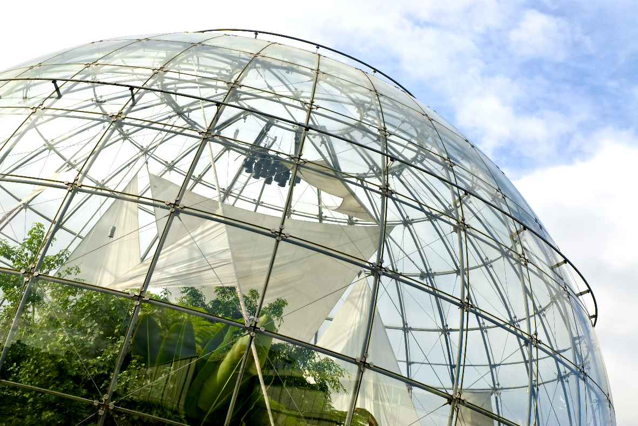**stated that the EU structural assistance made a positive impact on economic operations.

The Evaluation confirms that the EU structural assistance made a positive impact on all three areas of investments in infrastructure – health, education and social inclusion. As for the horizontal priority of sustainable development, the support under OPPC 2 priority, “Quality and Accessibility of Public Services: Health, Education and Social Infrastructure”, meets the criteria of investments in the development of manufactured and human capital. Interpreting the data collected and the results of analysis performed during the Evaluation, it can be stated that the EU structural assistance made a strong positive impact on the resources of both types of capital.

In summary, the impact of the EU structural assistance was insufficient to achieve long-term positive trends in the area of sustainable development. The Evaluation determined that the EU structural investments in economic operations and the management of the outcomes of the financial crisis could negatively impact environmental pollution indicators.

**Sustainability of EU structural assistance impact**

During the period of 2007–2013, the EU structural assistance impacted all areas of sustainable development and influenced all four types of capital in one way or another. To conclude the analysis of the impact of OPDHR, OPEG and OPPC on the objectives of sustainable development, the following trends can be distinguished:

• The EU structural assistance had a positive impact on the human and social capital resources not only implementing the soft, but also large-scale infrastructure investments. However, the impact scope of the EU structural assistance was significantly affected by the social and economic consequences of the financial crisis.

• The EU structural assistance had a strong positive impact on the manufactured capital resources, especially in transport and energy sectors. It is important to notice that this impact was direct and observed on both national and local level.

• The scope of the EU structural assistance in the area of the natural capital resources was insufficient to outweigh the consequences of economic development and for the environmental pollution indicators to reflect positive trends.

Assessing the sustainability of the EU structural funding, it can be concluded that the impact of the EU structural funding will be sustained either in most areas or in all areas, assuming that no drastic fluctuations of economic cycles will be faced in the future. However, to ensure the continuity of the EU structural funding impact on sustainable development it is essential to not only enable the results achieved by investing in infrastructure, but also to assure targeted investments in the area of environmental pollution reduction. Earlier researches draw attention to the fact that in the long term, in order to achieve and maintain stability, it is necessary to intensify efforts and initiatives leading towards this goal. Currently, there is still a trend which prevents entrenching the achieved results. Studies related to climate change suggest that when actions are taken at an early stage, the investments bring more tangible benefits at a lower cost than having taken appropriate actions in later stages. A study surveying green jobs reveals that investments in nature preservation have a positive correlation with the employment of people. This correlation gets particularly strong in the long term, improving the sustainability of economic activity. In addition to increasing employment, another important benefit of investments was distinguished: an improving quality of life of European citizens. Therefore, to ensure long-term benefits of these investments it is necessary to ensure that people are given the necessary skills to use the opportunities provided by new technology.

In conclusion, the impact of the EU structural funding on sustainable development in Lithuania has been limited, as the investments in human, social and manufactured capital reduced natural capital resources. Taking into consideration the negative social – economic situation and the global financial crisis in 2008, the majority of public government solutions (including the EU structural funding reallocation) were often directed towards short-term management of the crisis outcomes, and not towards the long-term outlook. The performed evaluation identified that for the 2007–2013 programming period an objective to not undermine the sustainable development priorities has been achieved to a greater extent, and in many cases the impact of the EU structural funding interventions was positive and sustainable.

|  |  |  |  |  |  |
| --- | --- | --- | --- | --- | --- |
| Table 3. EU structural assistance impact on sustainable development in Lithuania during 2007–2013 | | | | | |
| Operational programme | Priority | Type of capital | Sustainable Development Objective | Type of Impact | Scale of impact |
| **OPDHR** | 1 | Human capital | Tackling demographic and emigration problems | Positive | Strong |
| Social capital | Mitigating poverty and social exclusion | Positive | Strong |
| 2 | Human capital | Tackling demographic and emigration problems | Positive | Medium |
| Social capital | Mitigating poverty and social exclusion | Positive | Medium |
| 3 | Human and  social capital | Promotion of sustainable production and consumption | Positive | Medium |
| 4 | Social capital | Improved management of environmental resources | Neutral | - |
| **OPEG** | 1 | Manufactured capital | Promotion of sustainable production and consumption | Positive | Strong |
| 2 | Manufactured capital | Promotion of sustainable production and consumption | Neutral | - |
| 4 | Manufactured capital | Transport development and reducing negative environmental impact | Positive | Strong |
| 5 | Manufactured capital | Transport development and reducing negative environmental impact | Positive | Strong |
| **OPPC** | 1 | Manufactured capital | Tackling demographic and emigration problems | Positive | Medium |
| Natural capital | Improved management of environmental resources | Positive | Strong |
| Natural capital | Mitigating climate change and adapting to it | Neutral | - |
| 2 | Manufactured capital | Promotion of sustainable production and consumption | Positive | Strong |
| Human capital | Reducing public health threats | Positive | Strong |
| 3 | Natural capital | Mitigating climate change and adapting to it | Neutral | - |
| Source: concluded by Evaluators | | | | | |



In Lithuania, the services are provided by Deloitte Lietuva UAB and Deloitte verslo konsultacijos UAB (jointly referred to as “Deloitte Lithuania”) which are affiliates of Deloitte Central Europe Holdings Limited. Deloitte Lithuania is one of the leading professional services organizations in the country providing services in audit, accounting, tax, consulting, financial advisory, business advisory and legal services through over 90 national and specialized expatriate professionals.

© 2016 Deloitte Lithuania