SUMMARY OF THE EVALUATION OF THE ACHIEVED GOALS AND OBJECTIVES OF THE OPERATIONAL PROGRAMME FOR ECONOMIC GROWTH FOR 2007–2013

AIMS OF EU INVESTMENTS INTO ECONOMIC GROWTH AND FUNDS TO ALLOCATED ACHIEVE THEM

The Operational Programme for Economic Growth (hereinafter – the “OPEG”) was adopted on 30 July 2007 by European Commission’s decision No K(2007)3740. The programme was designed to facilitate long-term economic growth in order to reduce development disparities between Lithuania and the EU average. The main objectives of the programme were to increase (1) the share of high value-added business; (2) business productivity, especially by creating a favourable environment for innovation and SMEs; (3) the efficiency of economic infrastructure.

3,262 projects were implemented during the 2007–2013 financial period, for the total amount of EUR 4.12 billion (i.e. 47% of the EU funds for Lithuania in the period of 2007–2013). The projects created preconditions for increasing productivity as well as strengthening knowledge- and innovation-based economic sectors. In addition, a favourable business environment which supports innovation and efficient economic infrastructure were created, both of which contribute to fast economic growth.

STRENGTHENING PUBLIC RESEARCH AND DEVELOPMENT (R&D) BASE

The main outputs and results

Public R&D base was strengthened using funds under OPEG priority 1, objective 1. Projects under objective 1 financed the development of R&D infrastructure and the modernisation and purchase of modern scientific equipment in higher education and research institutions (hereinafter – HERI). Financing was also provided to the upgrading of the training and learning environment at universities and the creation of mobile scientific and demonstrative laboratories aimed at promoting pupils’ interest in science.
Centre For Physical Sciences And Technology

The project included building a unique Centre for Physical Sciences and Technology (hereinafter – the “CPST”). The CPST is the core of Sunrise Valley, where Lithuanian R&D and higher education capacity is concentrated. It employs 750 scientists and researchers. The centre laboratories covering the total area of 4,175 m², used for developing high technologies. 385 m² of the said area complies with cleanliness requirements under the ISO7 standard. The CPST facilitates next generation research and studies of the highest quality in the fields of laser light technology, materials science, nanotechnology, semiconductor physics and electronics.
EU financing enabled Lithuanian higher education and research institutions to create and upgrade their research infrastructure. No investments of such size have been made since 1990. To conduct high level research, laboratories with necessary equipment were built. In addition, open access points were installed to allow researchers from other R&D institutions and businesses to use the infrastructure, thus ensuring one of the preconditions for cooperation between them. In the long-term, it should facilitate cooperation of higher education and research institutions as well as increase their abilities to conduct high-level research. The new R&D infrastructure will facilitate the commercialisation of research results and increase R&D activities in both public and private sectors.

Results of the implementation of the objective:
- R&D infrastructure was created and modernised, facilitating active cooperation between HERI and business in future;
- by the end of 2015, 592 jobs were created in the research field, 145 contracts were signed with small and medium-sized enterprises and 228 laboratories were constructed and (or) upgraded;
- the number of researchers in the higher education sector increased by 3,337 between 2007 and 2014.

STRENGTHENING THE PRIVATE R&D BASE

The main outputs and results

Private R&D base was strengthened using funds under OPEG priority 1, objectives 3 and 4. Projects under objective 3 financed technical feasibility studies of R&D projects as well as business activities and investment into R&D and innovation, contributing to the creation of new knowledge-intensive enterprises and the expansion of R&D infrastructure of the existing enterprises. The EU Structural Funds provided support in the form of innovation voucher. Using this voucher supported enterprises could buy R&D services from HERI. Measures under objective 4 financed infrastructure and development activities at clusters (studies, training, marketing, management and administration of infrastructure). Moreover, financing was allocated to the creation, reconstruction and equipment of higher education and technology parks. Innovation support services for business entities, consultations on R&D and innovation, cooperation between HERI and business and the promotion and development of partnerships were also financed. Finally, measures under objective 4 supported promotional activities for modern technology and innovation, the dissemination of information about R&D and innovation programmes and the promotion of Lithuania’s achievements in the field.

The creation and development of spectroscopic UV-Vis-NIR analyser for multiparameter characterisation of dispersion flows
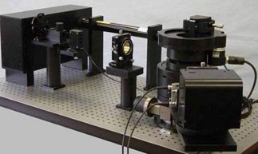
The project included the creation of three prototypes which substantially differ from products that are currently available on the market. After the completion of the project, the project implementer and higher education institutions will further be develop their cooperation. Higher education institutions will be able to use the results of the study and new joint projects will be conducted with Vilnius University and other institutions.
The evaluation has found that the implementation of objective 3 had the biggest impact on the attraction of private investment into R&D and innovation projects and on the creation and development of new products and services. Another evaluation included a beneficiaries’ survey which revealed that the measures had also contributed to the increased turnover of the supported enterprises, job creation, the improvement of enterprises’ production and services, the improvement of internal processes, the initiation of international R&D projects, the creation of new networks and the strengthening of cooperation between business and HERI. The impact on innovation activities of business was strengthened because support was provided to the full innovation implementation cycle – from testing the idea by a technical feasibility study to creating necessary R&D infrastructure and support for the implementation of specific R&D projects or research services.

The evaluations reveal that interventions under objective 4 contributed to the creation of new technology-based enterprises and the clusterisation process. Intervention projects created 215 new technology enterprises. The increase in the number of technology-based enterprises increases the demand for researchers, which results in more business investments into R&D. Moreover, 52 operating clusters and 9 higher education and technology parks should contribute to the further membership growth. However, so far the evaluations have not find the impact of these results on innovation and economic indicators. The impact will likely occur in the long-term.

Results of the implementation of these objectives:
- the number of researchers in enterprises increased by 2,574 between 2007 and 2014;
- the number of researchers per 1,000 people was 6.58 in 2014 (the aim of the strategic context indicator was 6.2);
- business expenditure on R&D increased to 0.3% of the GDP;
- the number of applications filed with the European Patent Office per 1 million population was consistently growing since 2009. In 2014, it was 16.61 (2.61 in 2009).

INCREASING BUSINESS PRODUCTIVITY AND IMPROVING BUSINESS ENVIRONMENT

The main outputs and results

Business productivity and environment were improved using funds under OPEG priority 2, objectives 1 and 2. Projects under objective 1 financed subsidies for technology upgrading and installation, the installation of management systems, management methods and information technology, the attraction of foreign and domestic direct investment and the improvement of enterprises’ international reputation. Activities such as the creation and development of enterprises, jobs creation, expansion into foreign markets, the organisation of special events and services to attract foreign direct investments (hereinafter – FDI) were financed by funds under objective 2. Moreover, various information events that promote entrepreneurship, the creation and development of small and medium-sized enterprises (hereinafter – SMEs), business partnership networks and franchise were financed as well. Finally, financing was provided to the creation, reconstruction and equipment of arts incubators. The implementation of the objectives was successful. The targets of the output and result indicators were achieved or will be achieved within the specified time after the project implementation.

The Evaluation of the Impact of the European Union Structural Assistance on Small and Medium-Sized Business Entities applied a counterfactual impact evaluation method to individual measures. It revealed the following:
- measure “Leader LT”, which financed the upgrading and installation of technology in enterprises, had a positive impact (+12%) on the growth of turnover and the increase in the number of employees (+11%), but did not have a positive impact on profitability;
- measure “New Opportunities”, which financed the presentation of enterprises and their production in international exhibition centres, did not have a statistically significant impact on the growth of turnover or the increase in the number of employees and profitability, but the impact will likely be felt in the long-term.

The said evaluation also included a beneficiaries’ survey which revealed that measure „E-Business“, according to beneficiaries, had a positive impact on profitability (+8%), but the impact of measure “Process LT” on the key business indicators was limited. Measure “E-Business” financed the installation of information technology in enterprises, while measure “Process LT” – the installation of management systems and management methods in enterprises. The 2007–2013 EU Structural Funds’ Impact Evaluation on the Competitiveness of Lithuania also revealed that positive effects of the investment would remain in the long-term.

The evaluation of the impact on SMEs shows that measure “Assistant-3”, under which various services were provided to SMEs, significantly contributed to the viability of enterprises, international competitiveness, entrepreneurship, the quality of products and the attraction of foreign investments. Measure “Assistant-1” financed various services to SMEs, while measure “Assistant-2” supported the creation, reconstruction and equipment of arts incubators. The evaluation concluded that the achievement level of aims established to measures “Assistant-1” and “Assistant 2” was average, i.e. the measures contributed to the increase in services provided by associated business structures and to the creation and development of art incubators. In general, the interventions mitigated some of the negative consequences of the 2007–2008economic crisis. The impact of the investments is likely to be felt in the long-term.

Results of the implementation of these objectives:
- EU investments created appropriate conditions for business productivity and export growth;
- EU investments contributed to the viability and entrepreneurship of enterprises;
- labour productivity (percentage of the EU28 average) increased from 47.9% in 2007 to 56.6 in 2015;
- the export value and the value of Lithuanian goods was increasing since 2007 and was 61% in 2015.

SUCCESSFUL IMPLEMENTATION OF FINANCIAL MEASURES AIMED AT BUSINESS DEVELOPMENT

The main outputs and results

Financial engineering measures aimed at business development were implemented under OPEG priority 2, objective 3. Two holding funds (JEREMIE Holding Fund and INVEGA Holding Fund) were created to implement financial engineering measures, while financial engineering measure “Guarantee Fund” and global grant measure “Partial Interest Compensation” were implemented separately. The measures aimed to improve the access of SMEs to external funding. The Funds provide loans and guarantees to SMEs and invest into SMEs which are in early (development and growth) stages and have a big potential for growth. The implementation of the objective was successful. All output and result indicators were achieved and exceeded.

Financial engineering measures which were implemented through the JEREMIE Holding Fund improved the access of SMEs to external funding for their development. Shared-risk loans helped to close the gap between supply and demand in the financial market, especially during the economic crisis. The financial measure of First Loss Portfolio Guarantee Loan and Portfolio Guarantee Leasing improved the access of SMEs to financing. Risk capital measures significantly contributed to the market’s formation and the development of a new business ecosystem, as well as stimulated investment activities by business angels.

Financial engineering measures implemented through the INVEGA Holding Fund increased the supply of financial sources to SMEs, eased the financial credit burden on SMEs and ensured that the Holding Funds’ investments would give returns.
Good practice of risk capital funds’ investment

Practica Seed Capital invested EUR 434,000 into start-up Trafi. The main Trafi’s product is a public transport journey planner app. Its distinguished quality lies in the fact that it plans journeys using real time processing of traffic, scientific algorithms and machine learning. It also allows users to post information about traffic disturbances as well as other important information. In 2015, US investors invested USD 6.5 million into the start-up. Currently, Trafi provides services in Lithuania, Latvia, Estonia, Turkey, Russia, India, Taiwan and Brazil. The Trafi app was made an official travel app of the Rio De Janeiro Olympics.

Results of the implementation of the objective:
- a venture capital market was created and developed in Lithuania (EU investments account for 69.3% of this market);
- from 2010 to 2016 supported enterprises paid EUR 35.5 million in taxes, invested EUR 13.3 million into R&D and created 1,300 new jobs (every EUR 1 million investment created 26 jobs);
- 11,054 SMEs used financial engineering measures and/or the partial interest compensation measure (a business entity could use financial engineering measures more than once);
- the evaluation of the impact on SMEs revealed that measure “Provision of Small Credits – Stage II” had an impact on the viability of enterprises. Credits had protected enterprises with temporary liquidity difficulties from bankruptcy.

PUBLIC TERRITORIES ADAPTED FOR THE PURPOSE INVESTMENT ATTRACTION

The main outputs and results

Creation of Marijampolė free economic zone. Stage I
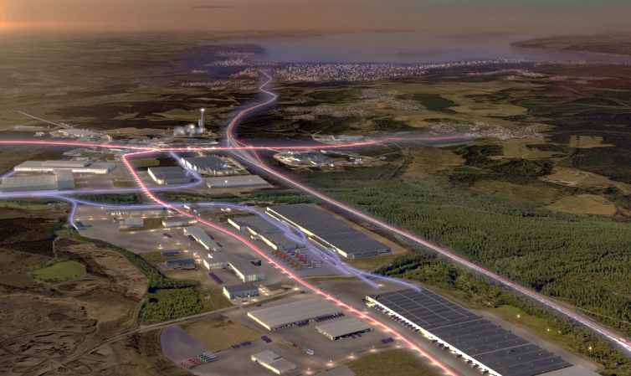
Engineering infrastructure created during the implementation of the project allows investors of Marijampolė FEZ to use the territory of 47.11 hectares. 15 industrial and storage lots were prepared for business. They have water supply and wastewater networks, drainage and surface water drain systems, street lighting, (access) roads and access to the electricity network. A Danish windows and doors company “Dovista” opened its office in Marijampolė FEZ and in the next four years is planning to invest around EUR 50 million into the development of a manufacturing factory which should create around 300 new jobs.

OPEG priority 2, objective 4 financed the adaptation of public territories for investment attraction. Projects under this objective supported investments into engineering networks and other transport infrastructure of industrial parks. Marketing activities of industrial parks and the improvement of the image of the Lithuanian business environment were also financed. The measure supported under objective 4 achieved its targets, i.e. facilitated the attraction of FDI. This objective together with other objectives had a strong impact on the attraction of FDI. The attracted FDI helped to create new jobs in Lithuania. A business survey conducted for the EU Structural Funds’ Impact Evaluation on the Competitiveness of Lithuania revealed that the creation of infrastructure (industrial parks, free economic zones) was one of the key reasons in attracting foreign business to Lithuania.

Results of the implementation of the objective:
- more foreign and Lithuanian investments were attracted by the adapted public territories;
- investments into ten industrial parks have already attracted 34 foreign investors;
- FDI to GDP ratio was 15.78pp higher in 2007–2013 compared to the scenario without EU investments, and 16.87pp higher in 2007–2015 compared to the scenario without EU investments.

DEVELOPMENT OF E-SERVICES AND INFRASTRUCTURE OF ELECTRONIC NETWORKS

The main outputs and results

The development of e-services and electronic network infrastructure was financed under OPEG priority 3. Projects under objective 1 of this priority supported the creation of e-government services, e-health services, e-learning services and intelligent management systems. Moreover, investments were allocated to the development of digital television and e-democracy, also to the digitisation of research data and resources of the Lithuanian language and culture. Finally, investments were made into the interoperability of public information sources (registers and information systems). The aim was to achieve that information systems in all state institutions used a single standardised data interchange model. The development of broadband electronic communication networks in rural areas with no commercial initiatives of this sector was financed under objective 2 of the priority. It also supported the development of measures to ensure the safety of information technology used by state institutions.

Impact of the interventions:
- compared to 2010, the share of population using public and administrative e-services doubled in 2015 (44%);
- the share of public services which can be accessed on the Internet increased from 37% to 95% between 2007 and 2013;
- the share of population which constantly uses the Internet reached 75% in 2015 (it was 58% in 2010). However, the impact of EU investments on the number of Internet users was a mild one. Other factors such as the increase in computer literacy, expansion of the Internet network, expansion of the mobile Internet, low prices of Internet service (due to high competition in the market) and creation of information and services such as e-banking, e-commerce, news, etc. were the key to increasing the number of Internet users;
- 5,775 km of optical cable was installed;
- according to the Eurostat data, in 2015 the broadband penetration rate in Lithuania was 67%;
- the share of population with a broadband Internet access increased between 2009 and 2015: in cities from 48% to 67%, in rural areas from 23% to 39%;
- the share of population with an Internet access increased between 2008 and 2015: in cities from 53.5% to 70.6%, in rural areas from 32.9 to 62.7%.
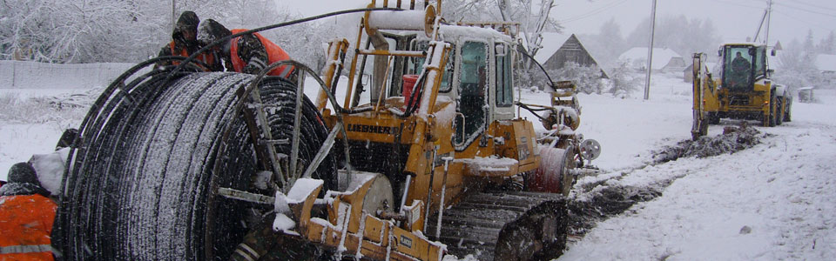
Development of the broadband network in rural areas – RAIN
The RAIN project aimed at providing residents, state and local institutions and business organisations in rural areas with access to broadband network services. It created the necessary infrastructure of in areas where no commercial initiatives of this sector existed. The infrastructure was created according to principles of open access and technological neutrality. The project connected public sector’s institutions (state institutions, municipal institutions, educational institutions, cultural institutions, health care institutions, etc.) established in rural areas to broadband network hubs. It also provided the possibility for businesses and private residents to have a broadband Internet access at home. The broadband network infrastructure was created in 982 towns and villages. To that end, 5,775 km of optical cable was installed. The infrastructure built during the RAIN project reached approximately 700,000 people. 51 network providers use the infrastructure to provide broadband network services to their customers.

DEVELOPMENT OF ENERGY INFRASTRUCTURE

The main outputs and results

The development of energy infrastructure was financed using funds under OPEG priority 4, objectives 1 and 2. Projects under objective 1 supported the modernisation of a power transmission system (by building power transmission lines, constructing and upgrading transformers and substations) and a gas transmission system (by modernising the existing gas transmission system and building new ones). The modernisation of a power distribution system (by building and modernising power distribution lines and transformer substations and changing power lines) and a heat supply system (by upgrading old district heating networks and building new ones) and the modification of energy network infrastructure (by reconstructing and moving energy objects) were carried out under objective 2.

Impact of the interventions:
- 12% of the district heating networks were upgraded (1,000 km), heat energy loss decreased from 19.6% in 2005 to 16.2% in 2015;
- the reliability of power supply increased for 240,000 consumers (14.2% of the total number of consumers) by modernising 774 transformer substations / switchgears;
- investments into the energy sector will additionally generate EUR 69.9 million in GDP by 2020;
- investments into the energy sector had an impact on employment. The number of people employed in the energy sector in 2007–2013 increased by 46 people, while in 2007–2015 – by 64 people, compared to the scenario without EU investments;
- the biggest impact of the EU Structural Funds on wages in the energy sector was felt in 2015, when wages in this sector were EUR 16 higher compared to the scenario without EU investments.
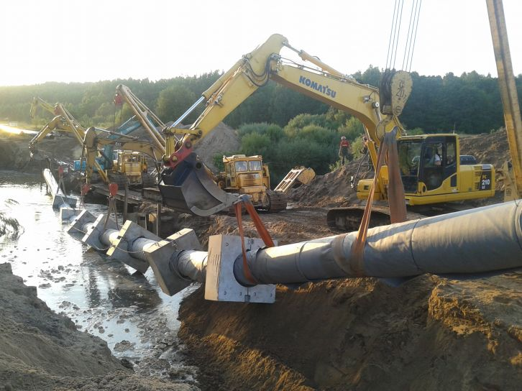
Construction of a gas transmission pipeline Jurbarkas–Klaipėda
The project was aimed to connect Lithuania’s transmission system to the circular system, thus ensuring a secure and reliable supply, distribution, transmission and storage of natural gas, as well as to facilitate the development of internal gas market and to connect Lithuania’s natural gas systems to EU systems. Moreover, it provided access to consumers from Tauragė, Šilutė, Šilalė, Pagėgiai and Klaipėda districts.
Project results: additional gas transmission system capacity developed (thousand m³/h) – 79.00; private investments attracted (million EUR) – 34.67; new gas pipelines built (km) – 137.88.

DEVELOPMENT OF TRANSPORT INFRASTRUCTURE

The main outputs and results

Transport infrastructure was developed using funds under OPEG priority 4, objectives 3, 4 and 6, and priority 5. Measures under these priorities financed infrastructure development of TEN-T network roads, railways, ports and airports. The modernisation of dangerous intersections, the installation of safe traffic and environmental measures in sections with an increased risk of accidents, the elimination of so-called “black spots”, the upgrading of railway management system for emergencies and crisis situations were financed by investments into land transport. Moreover, state roads and A roads of the TEN-T network were reconstructed (gravel roads were paved, road surfaces were improved and widened, roadside infrastructure was built), regional transport infrastructure and their connections with the main A roads were developed and bypasses were constructed. EU investments were also used to modernise the railway infrastructure and to improve railway capacity. The quality of transport services was improved, multimodal transport infrastructure was further developed and the creation of public logistic centres was facilitated. Finally, various road safety engineering and environmental measures were installed, including safety measures in roads of the TEN-T network, which significantly contributed to traffic safety and reduced negative impacts on the environment.

Impact of the interventions:
- the number of road accidents decreased from 6,448 in 2007 to 3,161 in 2015;
- 737 km of gravel roads were paved;
- 1,234 km of roads were built and reconstructed;
- 391.53 km of TEN-T network roads were built and reconstructed;
- investments generated 2.3 GDP per EUR 1 invested;
- despite the economic crisis, struggling world economy and decrease in the demand for services from Russia and Belarus, the volumes of rail freight remained similar (in 2015 it was 48 million tonnes per year);
- a new European railway gauge to Poland was built;
- railway safety and speed increased, while negative impacts on the environment decreased.

Investments into ports and airports aimed at developing infrastructure for local and regional navigation, increasing passenger service capacity and improving inland waterways. Moreover, the Klaipėda State Seaport was deepened, wharfs were rebuilt and reconstructed and the capacity of access roads, railroads and passenger service was increased. Finally, passenger terminals and airfield were modernised and expanded, the new fly safety and aviation safety measures implemented and passenger transit infrastructure developed.

Impact of the interventions:
Reconstruction of the existing section Kazlų Rūda–Kaunas and Marijampolė–Kazlų Rūda
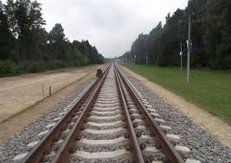
The project reconstructed one of the Rail Baltica sections. A 1,520 mm railway was reconstructed and a 1,435 mm gauge was built in the section between Marijampolė–Kazlų Rūda and Kazlų Rūda–Kaunas, which are one of the main sections, in order to connect Kaunas Central Railway Station to the European standard gauge railway. During the projects, the existing double-track railway line section was reconstructed and a parallel 1,435 mm gauge line was built. Moreover, railway objects were reconstructed, and Marijampolė, Vinčai, Kazlų Rūda, Jurė, Mauručiai, Jiesia and Kaunas stations and alarm, communications and power networks were modernised. As a result, the capacity of the railway transport infrastructure improved, thus increasing the speed. The projects contributed to the reduced travel time, noise and pollution, as well as to target of the objective by building railroads of the TEN-T network and reconstructing the existing railroads (114.22 km and 49.27 km, respectively).
- the new Marvelė cargo port was constructed and infrastructure (wharf, storage area, water supply, internal power networks, access roads) built in accordance with international requirements;
- the amount of cargo transported by Ro-Ro to the Klaipėda State Seaport increased from 4.1 million tonnes to 4.4 million tonnes between 2007 and 2015. The port’s workload grew despite the economic crisis;
- the number of passengers transported by Ro-Ro and Ro-PAX vessels increased by 84,000;
- the number of passengers in airports increased from 2.2 million in 2007 to 4 2 million in 2015;
- passenger terminals were reconstructed (built) in international Vilnius, Kaunas and Palanga airports;
- the volume of transport export increased: due to investments into the transport infrastructure, transport services exports’ ratio to GDP was 0.46% higher in 2007–2015, compared to the scenario without EU investments.

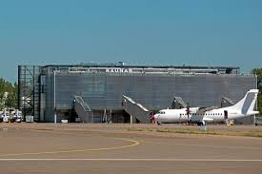
Modernisation of Kaunas airport

The project included the expansion of the airport apron, the construction of new taxiways and the replacement of the runway surface. To expand the airport apron and to build new taxiways, the area of 61,870 m² was paved and the pavement of a 3,250 m runway replaced. The modernisation of the airport has increased the number of passengers by 0.42 million (the aim was 0.28 million). This project together with other projects financed under the OPEG priority 5, objective 3, helped to exceed the objective’s targets.

Calculated by the authors according to final reports on OPDHR, OPEG, OPPC and TAOP.
Source of the figure: http://www.vu.lt/projektai/nacionalinis-fiziniu-ir-technologijos-mokslu-centras-lietuvos-aukstuju-technologiju-ateitis/
Source of the figure: http://www.sprana.eu/
Public Policy and Management Institute, 2011. Evaluation Services of Lithuanian Science and Business Collaboration Effectiveness and Coordination of Funding Possibilities. Commissioned by the Ministry of Economy of the Republic of Lithuania.
Ibid.
Ibid, 31–35.
ESTEP, 2015. 2007–2013 EU Structural Funds’ Impact Evaluation on the Competitiveness of Lithuania. Commissioned by the Ministry of Finance of the Republic of Lithuania.
BGI Consulting, 2014. Evaluation of the Impact of the European Union Structural Assistance on the Small and Medium-Sized Business Entities. Commissioned by the Ministry of Economy of the Republic of Lithuania.; Public Policy and Management Institute, 2011. Evaluation Services of Lithuanian Science and Business Collaboration Effectiveness and Coordination of Funding Possibilities. Commissioned by the Ministry of Economy of the Republic of Lithuania.; ESTEP, 2015. 2007–2013 EU Structural Funds’ Impact Evaluation on the Competitiveness of Lithuania. Commissioned by the Ministry of Finance of the Republic of Lithuania.
ESTEP, 2015. 2007–2013 EU Structural Funds’ Impact Evaluation on the Competitiveness of Lithuania. Commissioned by the Ministry of Finance of the Republic of Lithuania.
Source of the figure: http://www.trafi.com/
Source of the figure: http://lzinios.lt/lzinios/Ekonomika/marijampoles-lez-pasirengusi-priimti-investuotojus/213747
BGI Consulting, 2014. Evaluation of the Impact of the European Union Structural Assistance on the Small and Medium-Sized Business Entities. Commissioned by the Ministry of Economy of the Republic of Lithuania.
ESTEP, 2015. 2007–2013 EU Structural Funds’ Impact Evaluation on the Competitiveness of Lithuania. Commissioned by the Ministry of Finance of the Republic of Lithuania.
ESTEP, 2015. 2007–2013 EU Structural Funds’ Impact Evaluation on the Competitiveness of Lithuania. Commissioned by the Ministry of Finance of the Republic of Lithuania.
Source of the figure: http://www.statybunaujienos.lt/naujiena/Magistralinio-dujotiekio-statyba-naujas-greicio-rekordas/5903
Source of the figure: http://www.cargonews.lt/gelezinkeliai-uostai-aviacija/atidaryta-europine-veze-tarp-mockavos-ir-sestoku/
Ro-Ro means roll-on/roll-off.
Source of the figure: http://vz.lt/archive/article/2015/6/12/kaunas-su-20-mln-eur-uzsimojo-tapti-aviacijos-verslo-sostine#3

