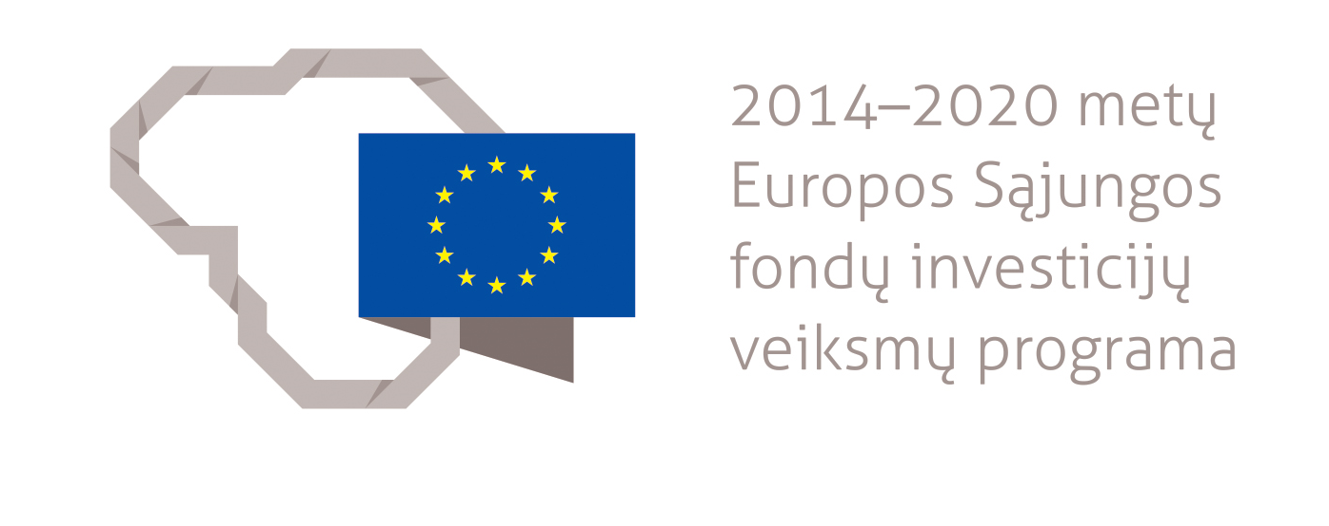

QUALITATIVE AND QUANTITATIVE EVALUATION OF THE ACHIEVEMENT OF GOALS AND OBJECTIVES SET UP IN THE OPERATIONAL PROGRAMMES FOR 2007–2013

2007–2013 eu sTRUCTURAL fUNDS INVESTMENT FOR LITHUANIA

Prepared by Visionary Analytics UAB in accordance with the service contract No 14P-40 signed on 16th of May 2016 between the Ministry of Finance of the Republic of Lithuania and group of economic subjects composed from ESTEP Vilnius UAB and Visionary Analytics UAB.

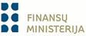 |  | 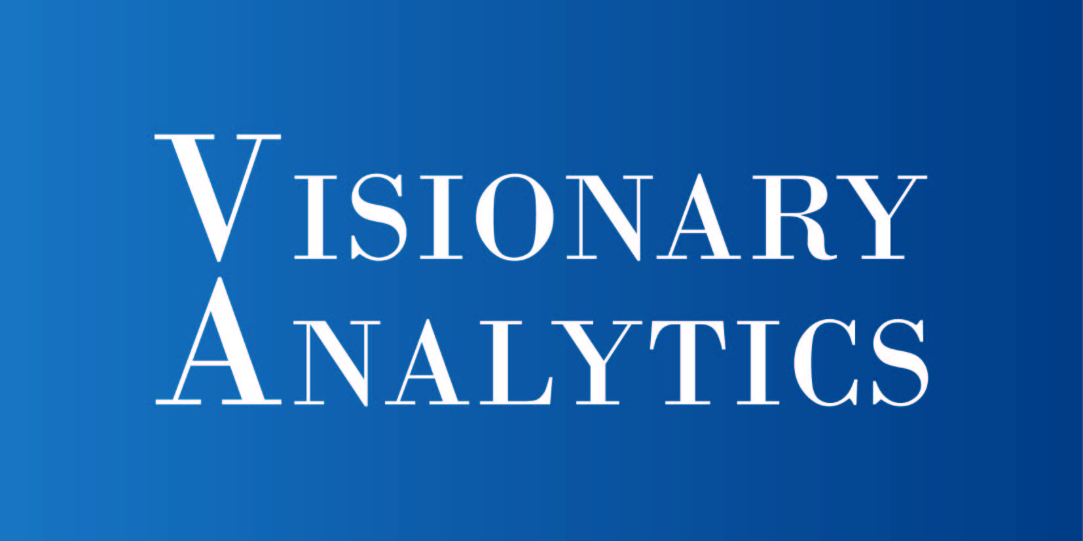

INVESTING EU FUNDS IN LITHUANIA IN 2007–2013
Lithuania received investments from the EU Structural Funds in 2007–2013 under the Lithuanian Strategy for the Use of the EU Structural Funds 2007–2013 and four operational programmes that were designed to implement it. The strategy closely followed a vision shaped by the Single Programming Document 2004–2006 – achieving the EU-15 level of socio-economic development so that all Lithuanian people could enjoy a better quality of life, i.e. increasing employment, good working conditions, growing income and user-friendly public services. A better quality of life also means a more integrated society with a reducing risk of poverty and social exclusion. This vision helped to set the main objective for investments made by the EU Structural Funds – rapidly improve conditions for investment, work and life in Lithuania to ensure that benefits of economic growth reach all Lithuanian people. The following three development objectives were also established:
- creating more and better jobs to mobilise the Lithuanian working age population and promote their active participation in economic activities and public life. New and better jobs is a precondition for creating a higher added value by the Lithuanian economy, ensuring stable income and a better quality of life for the working population and stopping the migration of skilled labour force from the country. An integral aspect of such job growth is the need to ensure high competence and continuous learning of the labour force;
- promoting economic growth in the long term to increase the competitiveness of the Lithuanian economy in international markets, develop knowledge-based sectors rather than capital or raw material intensive sectors, ensure macroeconomic stability and become a full member of the Economic and Monetary Union;
- developing social cohesion to ensure that Lithuanian people feel part of one community and different social groups share benefits of economic development.

These objectives served as a basis for three priority areas of the strategy: (1) productive human resources for a knowledge society; (2) competitive economy and (3) quality of life and cohesion. They were translated into three operational programmes contributing to the objectives and tasks established by the strategy (Operational Programme for the Development of Human Resources, Operational Programme for Economic Growth and Operational Programme for the Promotion of Cohesion) as well as a fourth operational programme for the management of the first three operational programmes (Technical Assistance Operational Programme) (see Figure 1).

Figure 1. Support from the EU Structural Funds by operational programme 2007–2013 (percentage)

Between 2007 and 2015, Lithuania used over EUR 7.9 billion allocated by the EU Structural Funds in the financial period of 2007–2013 (of which over EUR 7.4 billion was allocated to EU Structural Funds operational programmes). These funds were used for over 8,300 projects implemented by the public and private sector. In 2007–2013, the largest allocation by the EU Structural Funds operational programmes was made to environment and sustainable development (16.8%), development of trans-European transport networks (16.4%), local and urban development, conservation of cultural heritage and natural resources, and tourism development (12.7%). Most of the EU funds went to projects implemented in Vilnius, Kaunas and Klaipėda counties. Vilnius, Klaipėda and Alytus counties were at the top in terms of the investment received from the EU Structural Funds per capita.

The publication further describes achievements of the four operational programmes, discusses how investments made by EU funds between 2007 and 2013 affected the national economy and welfare of the population and overviews the achievement of the objectives established by each of the operational programmes.

IMPACT OF INVESTMENTS MADE BY EU FUNDS ON THE LITHUANIAN ECONOMY AND THE QUALITY OF LIFE IN 2007–2013
IMPACT OF INVESTMENTS MADE BY EU FUNDS ON GROWING GDP AND NATIONAL MACROECONOMIC INDICATORS

Investments by the EU Structural Funds made a positive impact on all key Lithuanian macroeconomic indicators, even a significant one in some cases. The main indicator showing the effectiveness of the use of the EU Structural Funds is an increase in the national gross domestic product (GDP) additionally created with investments made by the EU Structural Funds. Between 2007 and 2013, investments made by the EU Structural Funds significantly contributed to the national GDP growth, increasing it by 20% on average, and created over EUR 10.3 billion of additional nominal GDP during the period of 2007–2015. It is estimated that each invested Euro brought EUR 1.38 of nominal GDP in returns. This return on investment will continue growing and by 2020 will reach 1.6. The EU Structural Funds provided the greatest impetus to the GDP growth through increasing the share of gross capital investment and promoting domestic consumption.
In 2007–2013, investments made by the EU Structural Funds significantly contributed to the mitigation of negative effects of the global economic crisis that hit in 2008. Together with the government's structural reforms (tightened fiscal management, restructuring of state-owned companies), reoriented exports and growing domestic demand, these investments helped to manage the negative effects of the crisis and stabilise the national economy.

Investments by the EU Structural Funds played a crucial role in increasing gross capital investment. As a result, during the whole period of 2007–2015 expenditure on gross capital formation (material investment) were 17% (or EUR 10.5 billion) higher, although still below the pre-crisis level. Drastically shrinking the construction sector and tightening conditions for borrowing from banks, the economic decline was a key factor in the dynamics of the expenditure on gross capital formation.

The EU Structural Funds played an important role in the foreign direct investments (FDI) attraction process and in 2007–2015 contributed to a 16.5pp higher FDI to GDP ratio, compared to a scenario without investments. This was influenced both by EU Structural Funds’ financed measures which promoted the attraction of foreign investors to Lithuania and by high quality infrastructure created using EU funds, in particular the broadband network and transport and energy infrastructure. The overall impact of investments on the GDP growth had a significant effect on the FDI growth: an increasing economic level increases FDI. In terms of the sustainability of investments made by EU funds, it is estimated that the impact of EU financing on FDI is slightly decreasing and by 2020 will comprise 15pp of the GDP.

The positive impact the EU Structural Funds had on demand factors such as labour productivity and export competitiveness is indirect and therefore takes longer. It is estimated that EU investments had a positive impact on these indicators, too. As a result, in 2015 labour productivity was higher by 2%, household expenditure on consumption by 3.2%, import by 4% and export by 1%, compared to a scenario of economic development without EU investments.

In the period of 2007–20015, investments from the EU Structural Funds made a significant impact on the employment situation in the country. The net impact of the EU Structural Funds on job creation and preservation in 2015 amounted to 33,000 additional jobs. As a result, the employment rate in the 15–64 age group was higher by around 1.4%, while the unemployment rate was lower by 2.3% on average. Accordingly, the impact of investments on wage growth strengthened, leading to a 4% (or EUR 34.4) higher indicator in 2015, compared to a scenario without EU financing.

A positive effect of investments made by the EU Structural Funds on the GDP growth and a neutral impact on inflation led to a more rapid economic convergence with the EU average. According to EUROSTAT data, in 2014 Lithuania’s GDP per capita (based on purchasing power parity) was 75% of the EU-28 average. Without investments from the EU Structural Funds the latter figure would have been 3.8pp lower and would have made for 71%.

Furthermore, investments made by EU funds had a positive impact at the sectoral level. The main long-term beneficiaries (measured according to investment payoffs) were industrial and private services sectors, where the gains associated with growth in added value, preservation of jobs, attraction of investment and export of goods and services have been most significant. In 2007–2015, the EU Structural Funds investment payoffs in both industrial and private services sectors as measured by the effectiveness coefficient were twice as high as the investments made. On the other hand, financing from the EU Structural Funds had a significant short-term effect on the construction sector: between 2012 and 2015 around 15–17% of all jobs in the construction sector were created or preserved indirectly by the EU Structural Funds and the average wage rose by 14% (EUR 90.5).

IMPACT OF INVESTMENTS MADE BY EU FUNDS ON QUALITY EMPLOYMENT

One of the objectives of the use of the EU Structural Funds in 2007–2013 was to create more and better jobs in Lithuania. Based on the logic of programming documents, “a better job” is understood as a job which requires a higher qualification, creates a higher added value and has a higher chance to be preserved in the longer term. Almost 266,000 jobs were created or preserved by projects financed by the EU Structural Funds in 2007–2015. Slightly more than half (53%) of all the jobs created were temporary (short-term). 47% of the jobs were preserved for over a year after the project implementation and therefore could be considered long-term or permanent jobs.

The absolute majority (92%) of all the jobs declared by projects was created by measures financed by the European Social Fund. Good results in the field of employment were also a result of 2.5 times higher financing planned for the implementation of active labour market policy measures to deal with unemployment which increased in 2009–2010. Following the intervention, 45% of all participants remained in the labour market for over a year. A positive effect was made by a rather quick recovery of the Lithuanian economy after the crisis and the respective increase in the demand for labour force. Measures financed by the European Regional Development Fund created 19,800 jobs, of which 65% in companies carrying out activities assigned to high and medium high technology sectors. Most of the jobs created directly were long-term. Projects financed by the Cohesion Fund mostly created temporary jobs (i.e. only for the project implementation period) and mostly in the construction sector. Investments by this fund were channelled to the implementation of large-scale transport and environmental infrastructure projects.

With a lack of skilled labour, new jobs in different companies barely increased the total number of people working in the economy, i.e. the jobs created or preserved using the EU Structural Funds usually replaced or pushed out other jobs in the economy. Thus, the net impact of investment on employment in 2007–2015 was 33,000 new jobs. More than half (61%) of them are of high or very high quality.

EU investments contributed to the improving employment trends in the country. Between 2007 and 2015, the labour force participation rate increased by 6.2pp (from 67.9% to 74.1%). Investments were used to increase the qualification of workers and improve access to employment. The overall employment rate in 2007–2015 rose by over 2pp (from 65% to 67.2%). The employment rate of the elderly went up by more than 7pp (from 53.2% to 60.4%). EU investments helped to reduce the digital divide of the elderly and provide them with a better chance of staying in work or better access to employment. From 2007 to 2015, the share of working disabled persons increased by 1.6pp (from 27.2% to 28.8%). The interventions had a positive effect on the employment rate of women, which increased by 4.5pp (from 62% to 66.5%) between 2007 and 2015. Individual projects helped for women to balance family and work commitments and enter the labour market.

IMPACT OF INVESTMENTS MADE BY EU FUNDS ON THE QUALITY OF LIFE

One of the objectives of the use of the EU Structural Funds in 2007–2013 was to develop social cohesion and increase the quality of life. Between 2007 and 2015, the average annual added value created by Lithuanian counties was 0.4–0.83pp higher than it would have been without EU investment. EU investments had the greatest impact on the added value growth in Vilnius, Kaunas and Šiauliai counties. However, if calculating the impact per capita, the biggest benefits were enjoyed by people in Tauragė, Utena, Alytus and Šiauliai counties.

With a help of EU investments, the quality of life was better in many Lithuanian municipalities in 2014 compared to 2007 (the quality of life index improved in 42 municipalities). Major improvements were felt in health and education services, the quality of public infrastructure and living environment and security, i.e. those aspects of the quality of life which received most of the EU investments in 2007–2013. Direct contribution to the improving quality of life and material living conditions was made by the renovation of multi-apartment buildings, social housing development and investment into the upgrading and development of health, education, social services, transport, tourism, water supply and wastewater management infrastructure. EU funds made the greatest impact on the reduction of poverty and social exclusion through investment into material prosperity (promotion of recruitment and employment and provision of basic resources).
Figure 2. Quality of life index in Lithuania, 2014

EU investments had a positive impact on cultural services in terms of their volume (the implemented projects have increased the number of event-goers and events), variety (developed or significantly improved cultural services provided directly by establishments, educational activities and events, festivals and other activities) and availability. In 2007–2013, investments made by the EU Structural Funds played an essential role in preserving intangible cultural heritage, using its cultural and economic potential and increasing the interest of the Lithuanian population in cultural heritage.

ESTEP Vilnius UAB, Evaluation of the Impact of EU Structural Assistance 2007–2013 on Employment and other Macroeconomic Indicators of the Lithuanian Economy, 2016.
ESTEP Vilnius UAB, Evaluation of the Impact of EU Structural Assistance 2007–2013 on Employment and other Macroeconomic Indicators of the Lithuanian Economy, 2016.
Ibid.
Ibid.
Ibid.
Total number of employees in full time units is a number of employees converted into full-time units.
ESTEP Vilnius UAB, Evaluation of the Impact of EU Structural Assistance 2007–2013 on Employment and other Macroeconomic Indicators of the Lithuanian Economy, 2016.
ESTEP Vilnius UAB, Evaluation of the Impact of EU Structural Assistance 2007–2013 on Employment and other Macroeconomic Indicators of the Lithuanian Economy, 2016.
Ibid.
Ibid.
ESTEP Vilnius UAB, Evaluation of the Impact of EU Structural Assistance 2007–2013 on Lithuanian Cities and Small Towns, 2016.
The quality of life index consists of six sub-indices and 38 indices, reflecting material living conditions, business competitiveness, the quality of public buildings and living environment, security and demographic situation in a specific area.
ESTEP Vilnius UAB, Evaluation of the Impact of EU Structural Assistance 2007–2013 on Lithuanian Cities and Small Towns, 2016.
Ernst & Young Baltic UAB, Evaluation of the Impact of the European Union's Support on the Lithuanian Tourism Sector and Development Opportunities, 2013.
ESTEP Vilnius UAB, Evaluation of the Impact of EU Structural Assistance 2007–2013 on Culture, 2016.

